Project Development Phase

Performance Metrics
Date: | 15 February 2026
Team ID: | LTVIP2026TMIDS71508
Project Name: | Calculating Family Expenses Using ServiceNow
Maximum Marks: | 10 Marks

Model Performance Testing
S.No | Parameter | Values | Screenshot
1 | System Metrics | Expense Calculation Accuracy: Verified  Data Storage Accuracy: Verified  Report Generation Accuracy: Verified  Automatic Summary Update: Successful | 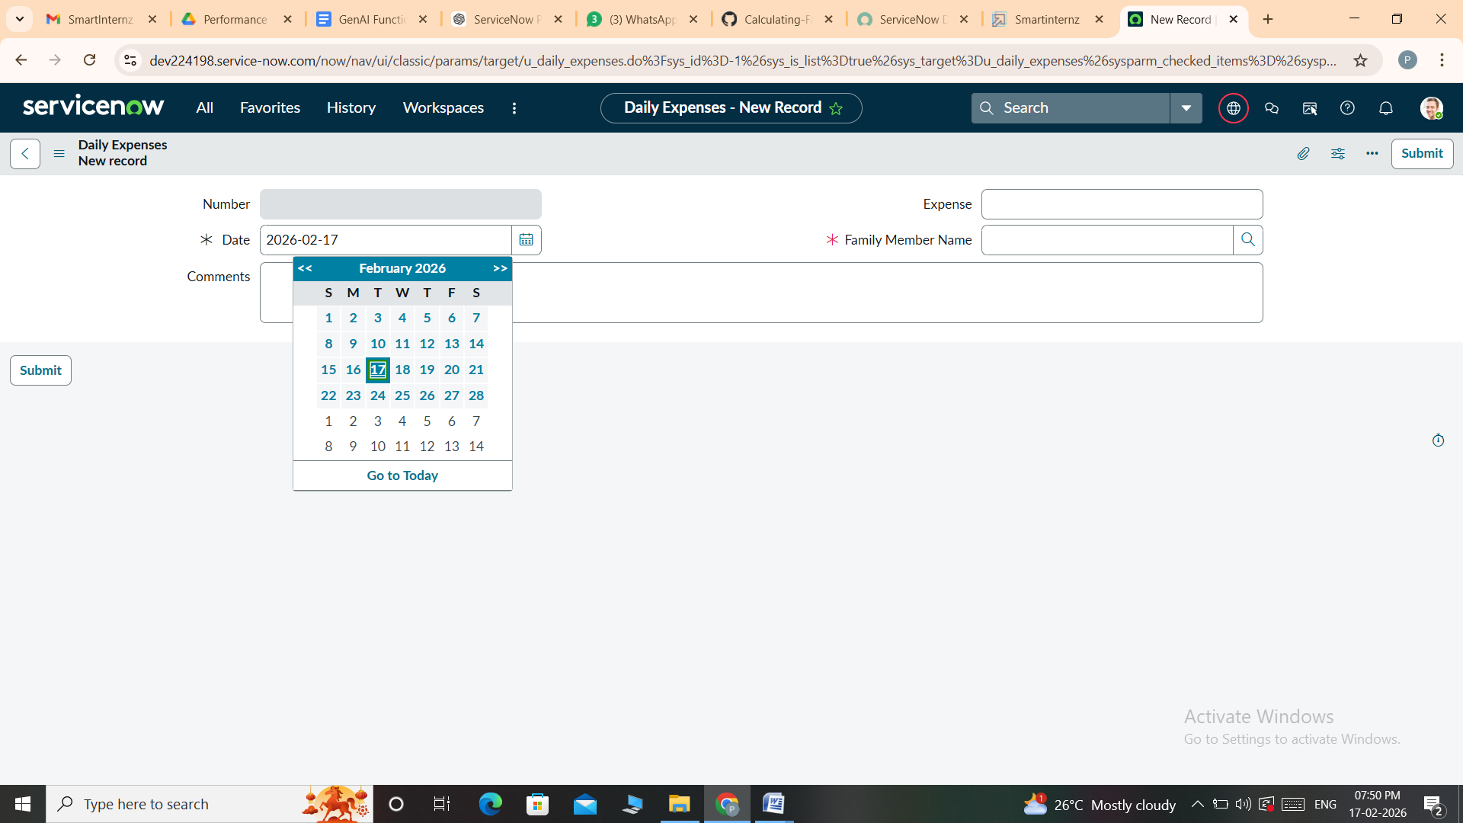
2 | System Optimization | Business Rule Optimization: Implemented  Form Validation Applied  Performance verified with multiple records | 